Shirley Ni

CSC 350, Section

Professor Kok

March 4, 2020

Group D

**Chapter 3 Cases**

**Case 4: Bayside Financial**

At Bayside Financial, where you work as a project manager, you have been asked to conduct user training sessions for a new information system. You must develop a specific schedule for the tasks (the estimated task duration for each is shown in parentheses):

• First, confirm arrangements for the training facility you plan to use (3 days).

• After you have confirmed the training facility, two tasks can begin at the same time: you need to send an e-mail message to all department managers announcing the training sessions (1 day) and you can develop the training material (5 days).

• As soon as the training material is complete, you can work on two tasks at once: arrange to have copies of handout material printed (2 days) and develop a set of PowerPoint slides (5 days).

• When the PowerPoint slides are ready, you conduct a practice training session with the instructor who will assist you (2 days).

• Finally, when the practice session is over and the handout material is ready, you can conduct the user training sessions (4 days).

Tasks:

1. Prepare a list showing all tasks and their durations
2. Confirm arrangements for the training facility that will be used
   1. Duration: 3 days
3. Send an email message to all department managers announcing the training sessions
   1. Duration: 1 day
4. Develop the training material
   1. Duration: 5 days
5. Arrange to have copies of handout material printed
   1. Duration: 2 days
6. Develop a set of PowerPoint slides
   1. Duration: 5 days
7. Conduct a practice training session with instructor
   1. Duration: 2 days
8. Conduct the user training session
   1. Duration: 4 days
9. Analyze the fact situation carefully to determine which tasks are concurrent and which ones are dependent on other tasks.

Sending an email to department managers and developing the training material are concurrent with each other and dependent on confirming arrangements for the training facility location. Arranging for copies of the handout material to be printed and developing a set of PowerPoint slides are concurrent with each other and dependent on the development of the training material. Conducting a practice training session is dependent on the development of the PowerPoint slides. Finally, the conducting the user training sessions are dependent on the completion of the practice session and the handout material being printed.

1. Create a PERT chart that shows the project. Use a format similar to Figure 3-18 on page 82. If project management software is available, use it to develop the chart.

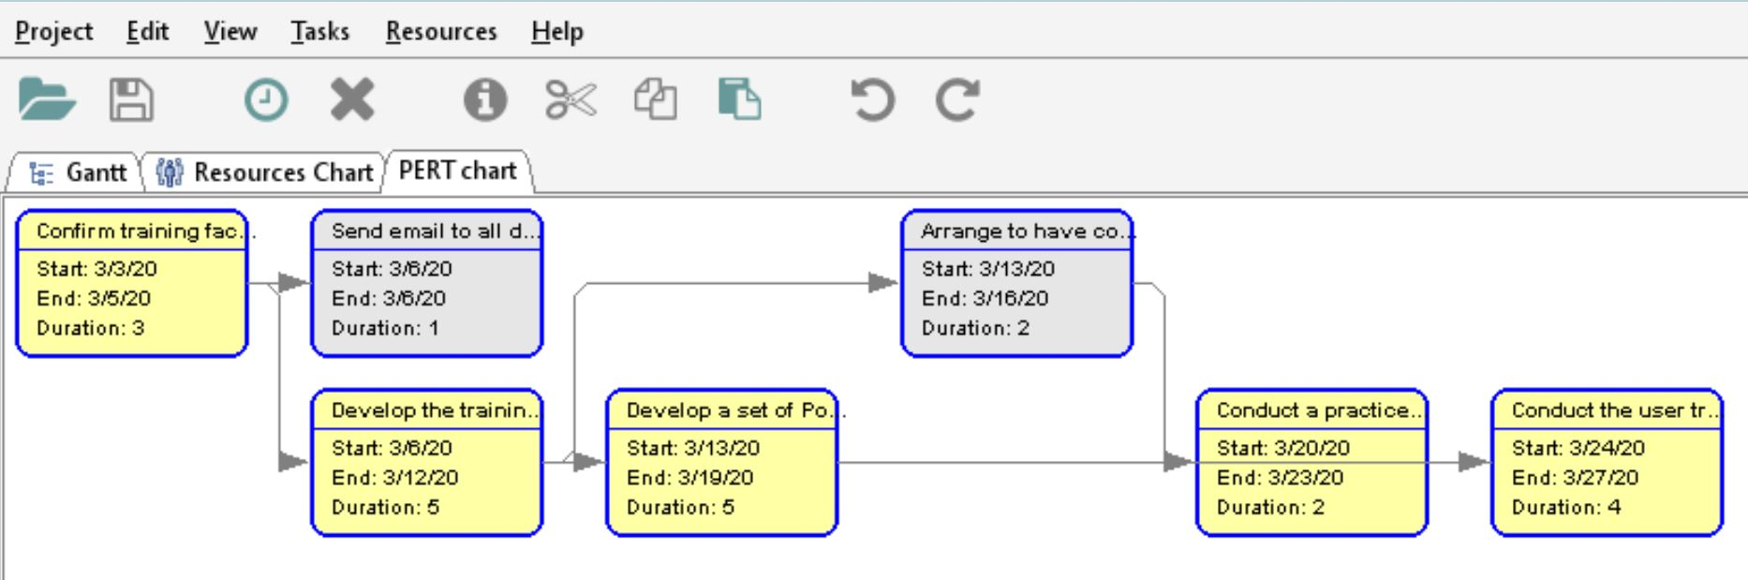

1. What is the critical path for this project? How do you know?

The critical path for this project is. The critical path can be determined by creating a Gantt chart of the list of tasks so that the critical chart can be highlighted.

